4 B.Conduct task analysis for an app and document user flows. Create corresponding wireframes using DIA.
🎯 AIM
To analyze user tasks in an online shopping application, document user flows, and create corresponding diagrams using the Dia tool.

📘 INTRODUCTION
Task analysis involves identifying the sequence of steps a user follows to complete tasks in an application. User flow diagrams visually represent these steps and improve system usability. Dia is an open-source diagramming tool used to create flowcharts, system models, and wireframes.

🧩 TASK IDENTIFICATION
The major tasks identified in the online shopping application are:
- Browsing products
- Searching for a product
- Adding products to cart
- Checkout process

🔄 COMBINED USER FLOW
Master Flow:
Start → Open App → Login/Register → Home Screen →
Browse/Search → Product List → Product Details →
Add to Cart → Cart → Checkout →
Shipping Details → Payment → Place Order → End
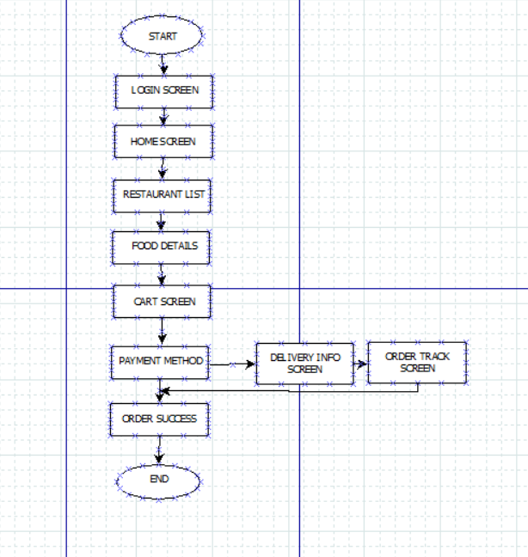

🔍 DETAILED TASK ANALYSIS
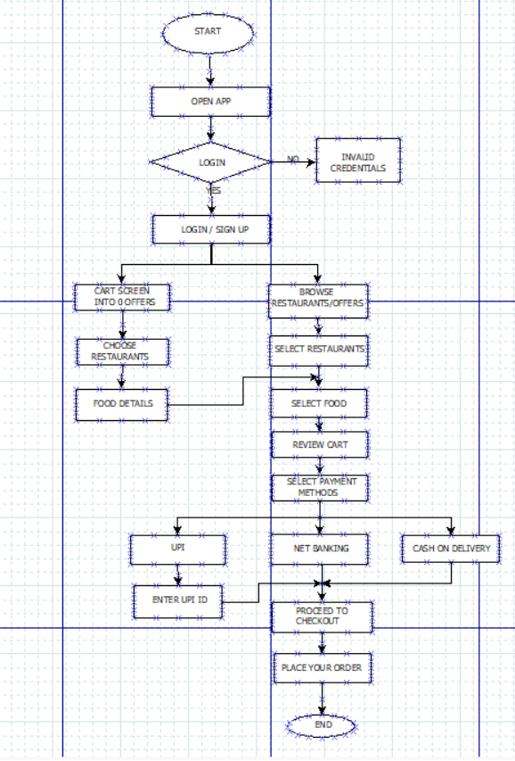
1️⃣ Browsing Products
- User opens home screen
- Selects product category
- Views product list
- Selects a product
- Views product details
Flow:
Home → Categories → Product List → Product Details

2️⃣ Searching for a Product
- User clicks search bar
- Enters product name
- Views results
- Selects product
Flow:
Search → Enter Query → Results → Product Details

3️⃣ Adding Product to Cart
- User views product
- Selects options (size, quantity)
- Clicks Add to Cart
Flow:
Product Details → Select Options → Add to Cart

4️⃣ Checkout Process
- User opens cart
- Reviews items
- Proceeds to checkout
- Enters shipping details
- Enters payment details
- Places order
Flow:
Cart → Review → Checkout → Shipping → Payment → Place Order

🔷 DECISION POINTS
- Is user logged in?
- Is product available?
- Continue shopping or checkout?
- Is payment successful?

🧱 WIREFRAME REPRESENTATION (IN DIA)
📱 Home Screen
- Search bar
- Categories
- Product display

📱 Product List Screen
- List/grid of products
- Filters

📱 Product Details Screen
- Product image
- Description
- Price
- Add to Cart button

📱 Cart Screen
- Selected items
- Quantity controls
- Total price
- Checkout button

📱 Checkout Screen
- Address form
- Payment options
- Place Order button

📱 Confirmation Screen
- Order success message

⚙️ PROCEDURE (USING DIA TOOL)
- Open Dia tool
- Create a new diagram
- Select Flowchart shapes from the toolbox
- Use shapes:
  - Oval → Start/End
  - Rectangle → Process
  - Diamond → Decision
- Add text to each shape describing the step
- Connect shapes using arrows
- Arrange diagram in proper sequence
- Use alignment tools for neat layout
- Save the file and export as image/PDF

📊 RESULT
The task analysis and user flow diagram for the online shopping application were successfully created using the Dia tool, clearly representing all user interactions.

🧾 CONCLUSION
- Task analysis helps understand user interaction
- User flow diagrams improve navigation design
- Dia tool provides an easy way to create flowcharts
- Helps in developing efficient UI/UX systems

